**Notepad++ Installation Guide**

You will need a text editor to write your Python code, and we recommend **Notepad++ for Windows users**. (We recommend **Sublime Text** for Mac users, but we do not include the installation guide for Sublime here.)

* 1. Visit <https://notepad-plus-plus.org/downloads/> . Download the latest release of Notepad++.
     1. You can choose “Installer” under “Download 64-bit x64”.
  2. Double click the downloaded installer file and follow the default settings to install Notepad++.

**Important:** After installing Notepad++, you must follow the instruction below to set up the Tab Settings properly. Otherwise, you may encounter problems running Python code.

1. Go to “Settings” on the top menu of Notepad++ and find “Preferences…”. You’ll see a window popping up, as shown below.
2. Choose the “Language” tab.
3. On the right-hand side, you’ll see a checkbox that says “Replace by space”. Tick this checkbox, as shown below.

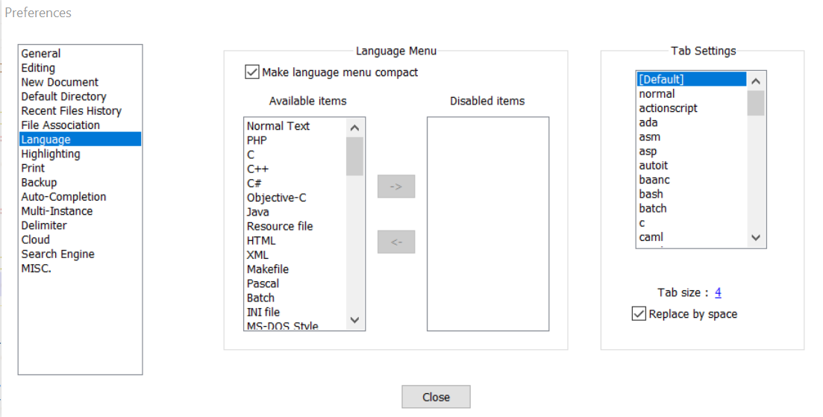

If you face issues during the installation, don’t worry. We will help you in class in Week 1.

See you soon!